Note: This document is “view only”. Please create a copy of this document and save it to your drive.

**SOP- Weekly Metrics- Systems Vault**

**PREREQUISITES**

[Master: SOP- Metrics - Systems Vault](https://docs.google.com/document/u/0/d/1R2L8bjwos9LwUZcVbuGmYS2mSQWj5vWXTGoV-vsrO14/edit)  
[Master: Metric & KPI Planning & Tracking- Systems Vault](https://docs.google.com/spreadsheets/d/1OTXpFNDUCOTQ1BeItyQ49McrzLW6TKo5H906EhZC2Dc/edit?usp=sharing)

Google Analytics - sarah@sarahnoked.com

[Teamwork PM](http://sarahnoked.com/teamwork)

[Ontraport](http://sarahnoked.com/ontraport)

[Loom](https://www.loom.com/)

**PURPOSE**Tracking metrics and key performance indicators weekly gives us insight into how the business is performing and enables us to make business decisions backed up by numbers. Tracking metrics weekly also allows us to see trends emerging.

**POLICY**

Metrics are tracked weekly and updated here [SN Master: Metrics](https://docs.google.com/spreadsheets/d/19wmGf9HFWkDmUCWjUwcCZK_6MeDgxJS05N9-6SPo07I/edit?usp=sharing) in the tab “2020- Weekly KPIs & Metrics”

There is a recurring task in [Teamwork](https://sarahnoked.teamwork.com/#/home/projects) to track report metrics weekly and create a walkthrough of findings via [Loom](https://www.loom.com/).

Metrics are reported via Screencast (Loom) and sent through the INTERNAL channel in [Teamwork Chat](https://sarahnoked.teamwork.com/chat/channels/55606) with a mention to @all and @sarah

Color the stats green for positive/increased results and red showing negative/decreased results.

For Facebook Ads Stats, we communicate with the FB ads team via [Slack- FB Ads Team](https://app.slack.com/client/T016QD1B3CY/G016LJQP412/thread/G016LJQP412-1594710634.007500)

When checking metrics in the Dashboard, please double check the figures by right-clicking on the number > Open Link in New Tab. Sometimes, the figures shown in the Dashboard are not accurate, and sometimes our test contacts are included, so we need to deduct that from the figures.

**PARTY**

Online Business Manager

**PROPERTY**

Online Business Manager

**PROCESS**

Part 1: Sign in to [Google Analytics](https://analytics.google.com/analytics/web/) - [sarah@sarahnoked.com](mailto:sarah@sarahnoked.com) and pull metrics

Part 2: Sign in to [Ontraport](https://ontraport.com/) and Pull Metrics

Part 3: Communicate with the FB ads team via [Slack- FB Ads Team](https://app.slack.com/client/T016QD1B3CY/G016LJQP412/thread/G016LJQP412-1594710634.007500)

Part 4: Sign in to [Stealth Seminar](https://stealthseminarapp.com/) and Pull Metrics

Part 5: Finalize Conversion Rates and Include Comments on Findings

Part 6: Report Monthly Metrics

**PROCEDURE**

**Part 1: Sign in to** [**Google Analytics**](https://analytics.google.com/analytics/web/) **-** [**sarah@sarahnoked.com**](mailto:sarah@sarahnoked.com) **and pull metrics**

1. Make sure to switch to Sarah’s account 
2. Make sure it says All Accounts > Sarah Noked 
3. Go to Conversions > Goals > Overview on the left side of the screen 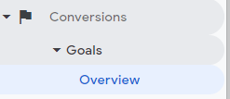
4. Change the date to the right date range 
5. The dashboard will then be updated, then collect all relevant data as specified per goal on the spreadsheet   
   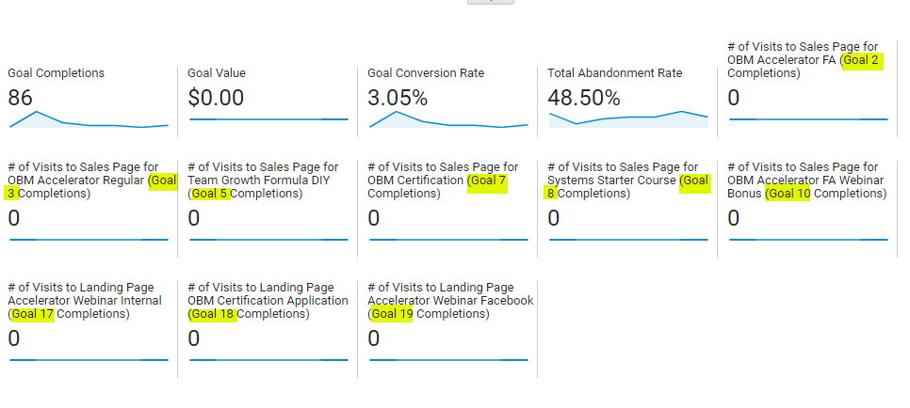

**Part 2: Sign in to** [**Ontraport**](https://ontraport.com/) **and Pull Metrics**

1. Login and go to Dashboard
2. Go to the respective metric boards and update the dates accordingly
   1. The metrics for “# of Signup Accelerator Webinar FACEBOOK + INTERNAL” can be found under contact group “ALL- COBM Evergreen Webinar Registrants”. Get the total number of people in the contact group.
   2. For OBM Cert Funnel Email Metrics, head over to campaigns and select “PRODUCT: OBM CERT APPLICATION INTAKE”. Change the date to the right date range.
      1. Hover over the email you want to gather metrics from and select the small box icon to see the open rate.

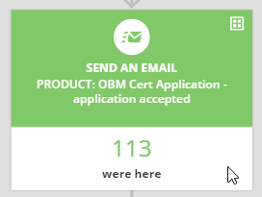

* + 1. Refer to the goal following the email to get the number of purchase

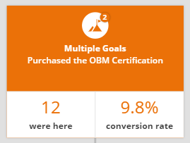

* 1. For Accelerator Funnel Email Metrics, head over to campaigns and select “PRODUCT: COBM Accelerator Evergreen Webinar Delivery”. Change the date to the right date range.
     1. Hover over the email you want to gather metrics from and select the small box icon to see the open rate.
     2. Refer to the goal following the email to get the number of purchase

PRODUCT: COBM Accelerator Evergreen Webinar Delivery

**Part 3: Communicate with the FB ads team via** [**Slack- FB Ads Team**](https://app.slack.com/client/T016QD1B3CY/G016LJQP412/thread/G016LJQP412-1594710634.007500)

1. Go to [Slack- FB Ads Team](https://app.slack.com/client/T016QD1B3CY/G016LJQP412/thread/G016LJQP412-1594710634.007500)
2. Tag the FB ads team and ask for the needed info with a specified time frame
3. Update the spreadsheet accordingly

**Part 4: Sign in to** [**Stealth Seminar**](https://stealthseminarapp.com/) **and Pull Metrics**

1. Go to My Webinars and click View Stats
2. Change the date to the right date range and click Apply Filters
3. The webinar stats will then be updated, then collect all relevant data as specified per goal on the spreadsheet
4. To pull metrics on number of registrants, scroll down and you’ll see it along the list of emails.

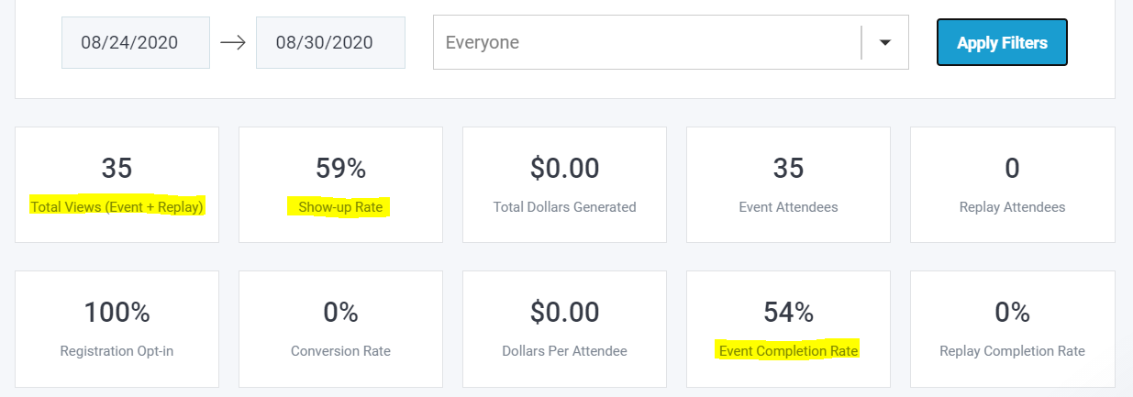

**Part 5: Finalize Conversion Rates and Include Comments on Findings**

1. Leave any appropriate notes under the Comments tab
2. Color the stats **green** for positive/increased results and **red** showing negative/decreased results.

**Part 6: Report Monthly Metrics**

Sarah and OBM have a recurring monthly agenda task to discuss metrics

**Created by:**

**Department:** Metrics

**Date:**

**Revised:**

**Revised by:**